

Managed Endpoint Security Services


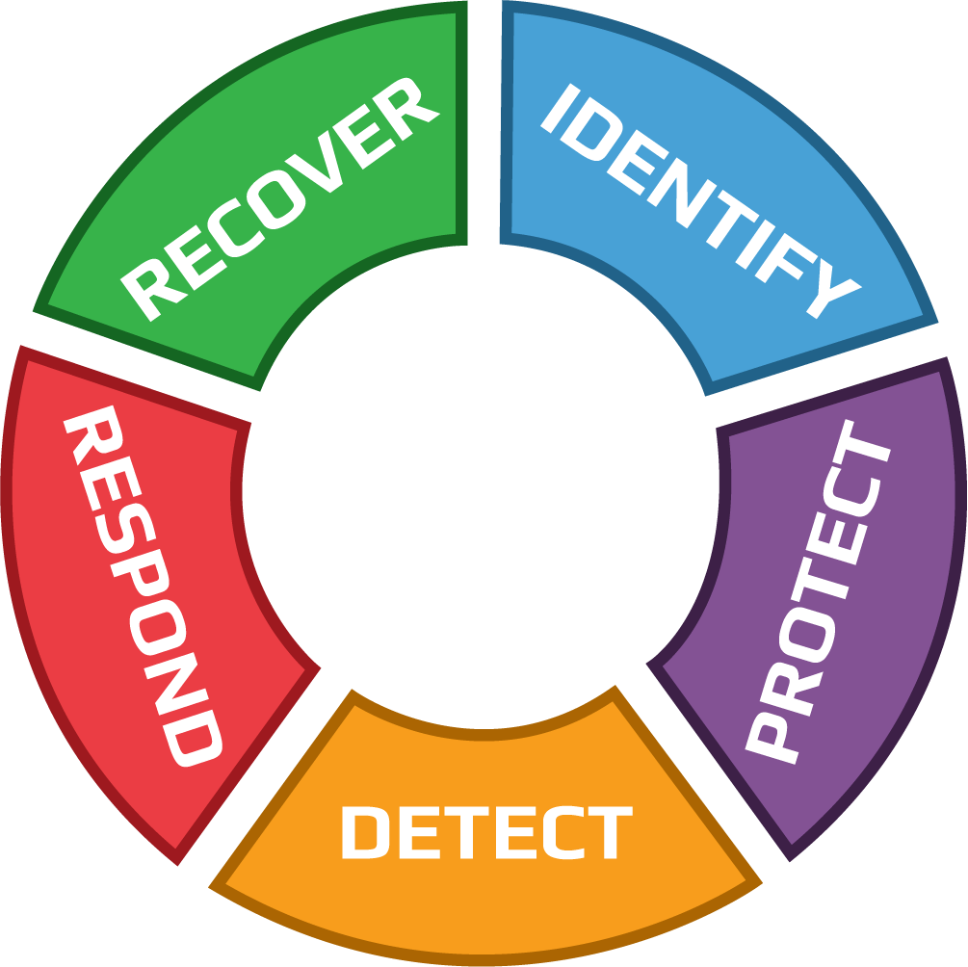

IDENTIFY

Managed Endpoint Identification Services
- Monthly and On-Demand NIST-Based Asset Management Report & Cyber Posture of Devices and new CISO Portal.
- Device Cyber Lifecycle Management (Onboarding, Ongoing, and Decommissioning/Offboarding).
- Automated Tools to Set, Enforce, and Capture Proper Configuration/Controls:
  - On Desktops, Laptops, Servers, Virtual Servers, Smartphones & Tablets.
  - Enforced Without User Involvement.
  - Tamper Protection to Prevent Users and Hackers from Disabling or Changing Settings.
  - Device Settings: Complex Password, Computer Firewall, Logs, Screen Saver, OS Patches, etc.
  - Cyber Tools: Remote Monitoring, Full-Disk Encryption, Endpoint Protection (Antivirus, Anti-Malware, Anti-Ransomware, and Behavioral Analysis) with EDR (Endpoint Detection & Response) and SOC (Security Operation Center), Computer MFA.
- Threat & Vulnerability Identification.
- Options:
  - User Credential Management Recommendation and Configuration Support.
  - Web Application Gateway to Private Data System.
  - Correlation of Users, Devices & Web Applications with Private Data.

PROTECT

Managed Endpoint Protection Services
- Data Loss Prevention through Managed Endpoint Protection:
  - Antivirus, Web Protection, Network Protection, Peripheral Protection, etc.
  - Malware Detection & Blocking.
  - Full-Disk Encryption with Key Retention & Restoration Services.
  - Data Leakage Protection with Content Filtering (Advanced Configuration).
- Email Encryption Guidance & Recommendations.
- Mobile Device Management: OS version, status of enabled security features (configured or disabled), full disk encryption, mobile device biometrics (Face ID/Touch ID); screen lock or tampered (jailbroken).
- Multi-Factor Authentication to Access Endpoints.
- Options:
  - Cloud-Based Firewall with Always-On VPN.
  - Multi-Factor Authentication to Access Web Applications with Private Data.
  - Data Backup.
  - Disaster Recovery / Computer Image Backup.

DETECT

Managed Endpoint Detection Services
- 24×7 Performance & Availability Monitoring.
- 24×7 Cyber Threat Monitoring.
- 24×7 Cyber Compliance Monitoring.
- Endpoint Intrusion Detection & Prevention.
- Security Incident Event Monitoring & Management.
- Log/Data Aggregation.
- Real-Time Security Alerts & Reporting.
- Insider Threat.

RESPOND

Managed Endpoint Response Services
- Active Automated Incident Response.
- Cyber Expert Incident Response.
- Mass Vulnerability Response for Imminent Risk (Zero-Day, etc.): When a High Risk is Known But No Solution is Yet Available.
- Incident Response Support:
  - Cyber Incident Handling & Forensic Analysis During an Incident.
  - Breach Determination.
  - Evidence Gathering and Preservation.
  - Documentation.
  - Evidence Presentation to Regulators, Authorities (FBI), and Cyber Insurers.

RECOVER

Managed Endpoint Recovery Services
- Automated Recovery Services.
- Cyber Expert Recovery Services.
- Options:
  - Full-Disk Encryption assistance for key recovery.
  - Image Backup Restoration Recovery Services.

